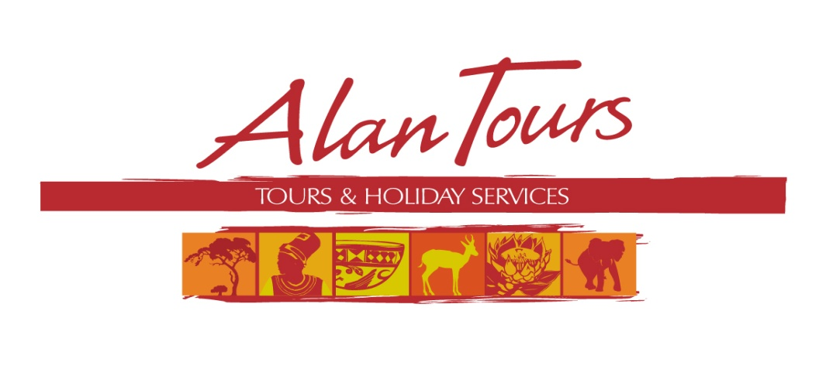

Alan Fogarty, Tours and Holiday Services c.c.

Close Corporation no. 2005/15064

Tel: +27 (0) 41 378 1486

Fax: +27 (0) 86 603 3701

[info@alantours.co.za](mailto:info@alantours.co.za)

[www.alantours.co.za](http://www.alantours.co.za/)

**Half Day Tours 2014-2015**

**Valid 1 November 2014 - 31 October 2015**

Single travellers welcome (30% single supplement)

Group rates available on request

http://www.alantours.co.za/images/gallerybanner.jpg

|  |  |  |  |
| --- | --- | --- | --- |
| **Tour** | Code | **Half Day Tours** | ZAR |
| Half Day Tour | HD01 | **Addo Elephant National Park**  **Exciting and informative game drive through the Addo Elephant National Park. The reserve is home to more than 600 Elephants, Lions, Buffalo, Zebra, Eland and Antelope amongst the many other species of animals and bird life.**  **Departure: 7:30**  **Duration: +- 5 hrs**  **Included: transfers, entrance/conservation fee, bottled water** | 1 050.00 pp |
| Half Day Tour | HD06 | **City and Township Tour with Red Location Museum**  **Get an overview of the history of Port Elizabeth, the first inhabitants and settlers. A glimpse into the pain of apartheid and life in the oldest Township in Port Elizabeth, New Brighton. View the historical area and the award winning Red Location Museum.**  **Departure: 9:00 or 14:00**  **Duration: +- 3-3.5 hrs**  **Included: entrance fee, drink in tavern, bottled water** | 650.00 pp |
| Half Day Tour | HD14 | **Cape Recife and Lighthouse Tour**  **Where sea meets shore. An excursion highlighting the cultural, historical and natural diversity at the entrance to Algoa Bay.**  **Departure: 9:00 or 14:00**  **Duration:+- 3-3.5 hrs**  **Included: entrance/conservation fee, bottled water** | 490.00 pp |
| Half Day Tour | HD15 | **Route 67**  **In remembrance to the 67 years that Nelson “Rolihlahla” Mandela gave of his life to the democratization and normalization of South African society Port Elizabeth has developed a walking route as an interactive art journey.**  **Departure: 9:00 or 14:00**  **Duration: +- 3-3.5 hrs**  **Included: entrance fee, bottled water** | 390.00 pp |
| Half Day Tour | HD10 | **Marine Safari into Algoa Bay**  **Travel through the protected waters of Algoa Bay with the possibility of spotting Dolphins, Seals, Sharks and seasonal Southern Right and Humpback Whales. Circumnavigate St Croix Island host to the largest breeding colony of African Penguin in the world.**  **Departure: 8:30**  **Duration: +- 3.5 hrs**  **Included: transfer, boat tour, bottled water** | 1 100.00 pp |
| Half Day Tour | HD05 | **Bird watching in and around Port Elizabeth**  **A guided tour of SAMREC, the marine re-habilitation centre and the operational lighthouse at Cape Recife. Search the shoreline for the many species of Waders, Shore and Marine birds that utilize this important area, the endangered Black oystercatcher and Rosette tern amongst the many different species.**  **Departure: 7:30**  **Duration: +- 5 hrs**  **Included: transfer, entrance fees, bottled water** | 650.00 pp |
| Half Day Tour | HD08 | **Woody Cape Dune Fields and Canopy Forest walk**  **Home to the world’s first nation, the Khoikhoi. Walk in the expansive dune fields with uninterrupted views of the Indian Ocean and Bird Island. Explore Khoikhoi middens: ancient heaps of millions of discarded seashells on this remote and awe-inspiring shoreline. Wander through the shaded dune forest accompanied by the song of the rich forest birdlife while Vervet monkeys climb overhead.**  **Departure: 8:00**  **Duration: 6 hrs**  **Included: entrance/conservation fee, fresh coffee, bottled water** | 1 250.00 pp |
| Half Day Tour | HD04 | **City Tour – Port Elizabeth**  **Get an overview of the history of the Bay and the City of Port Elizabeth, an insight into the first inhabitants, the Khoikhoi, the early European mariners, Xhosa and early Boers, the arrival of the British 1820 settlers. Of 100 years of warfare and view the rich colonial architectural heritage of the City and surrounding areas.**  **Departure: 9:00**  **Duration: +- 3.5 hrs**  **Included: transfer, bottled water** | 490.00 pp |
| Half Day  4 x 4 Tour | HD12 | **4 x 4 Safari – Cape Recife and Grysbok Nature Reserve**  **Morning game drive through a coastal wonderland, spot the iconic Springbok, Zebra, Red Hartebeest and endemic Grysbok. The surf zone and sand dunes are a bird watchers paradise. Discover the many uses the ancient Khoikhoi people had for the hardy plants which occur here.**  **Departure: 8:30**  **Duration: 2.5 hrs**  **Included: entrance fee, bottled water**  **Sunset game drives make use of a powerful spotlight to find elusive nocturnal creatures such as Owls, Bushpig, Porcupine and Caracal. At sunset we take break for a glass of wine and snack before continue searching for nocturnal creatures.**  **Departure: April-August: 15:30**  **September-March: 16:00**  **Duration: 3.5 hrs**  **Included: entrance fee, bottled water, glass of wine at sun set, snacks** | morning drive  275.00 pp  sunset drive  375.00 pp |
| Half Day Tour | HD02 | **Arts & Antiques Tour Port Elizabeth**  **We visit the historical suburb of Port Elizabeth, galleries, Arts and Antique shops, artists in New Brighton and the award winning Red Location, a Museum to the struggle for democracy.**  **Departure: 9:00**  **Duration: +- 4 hrs**  **Included: entrance fee, bottled water** | 650.00 pp |
| Half Day Tour | HD09 | **School excursion**  **Experience the challengers faced in these impoverished communities that never forget to laugh. Visit a farm school in a rural learning environment. Interact with teachers and children in a suburban school while exploring their classrooms.**  **Departure: 8:00**  **Duration: +- 3.5 hrs**  **Included: bottled water** | 490.00 pp |
| Half Day Tour | HD13 | **Best Beaches Sundowner**  **Enjoy a Sun downer picnic on one of the fantastically beautiful beaches around our Friendly City to watch the sunset over the Indian Ocean and soak the atmosphere.**  **Departure: +- 17:00 depending on the time of the year**  **Duration: +- 3 hrs**  **Included: refreshments, snacks, wine/beer** | 490.00 pp |
| Half Day Tour | HD11 | **Guided walk through the Golden Sands of Southern Seashore**  **Depart via the Wild Side coastline overlooking the rocky shoreline and intertidal zone. Take an interpretive and interactive look at the intertidal ecology of the Southern seashore and examine middens, ancient heaps of millions of discarded seashells, left by the early Khoikhoi.**  **Departure: 8:00**  **Duration: +- 4 hrs**  **Included: transfer, guided walk, bottled water** | 550.00 pp |
| Half Day Tour | HD07 | **Kragga Kamma Game Park** **African Big game on our doorstep and a chance to interact with adult Cheetah.**  **Departure: 9:00 or 14:00**  **Duration: +- 3-3.5 hrs**  **Included: entrance fee, bottled water**  **Excluded: Interaction with Cheetah** | 650.00 pp |

http://www.alantours.co.za/images/gallerybanner.jpg

Wamkelekile eAfrica

Welcome to Africa